**Project Report**

**On**

**“Flight Reservation”**

By

Manisha

**STUDENT DETAILS**

|  |  |  |
| --- | --- | --- |
| Batch Name | : | HPPRO |
| Name | : | Manisha |
| Student Id | : | S161107200685 |
| Branch Name | : | NIIT Gurgaon Sector 14 Center |
| Training Faculty | : | Bala Murthy |
| Supporting Faculty | : | Rakesh Pandit |

**LIST OF SYMBOLS**

|  |  |  |
| --- | --- | --- |
| S No | Symbol | Nomenclature & Meaning |
| 1 | QTP | Quick Test Professional |
| 2 | ALM | Application Lifecycle Management |

1. **ABSTRACT:**

The Proposed project is customized software solution for testing standalone(windows) Flight reservation system.

This project contains the tests to automate login,registration,logout

UFT is used to automate test and other test requirements like:

* Random selection of tickets
* Random selection of flights.
* Validating total ticket amount
* Iterate reservavtion test 3 times.
* Fetching order number in output parameter.
* Creating inputbox to input mode of flights.

ALM is used to map requirements and test cases.

1. **About HP Testing:**

Software testing and quality assurance, focuses ofn software testing as a critical phase in SDLC to ensure efficient and bug-free software.This course explains the difference between quality assurance and quality control activities and how they complement each other.this course introduces the phases of testing lifecycle and goes on to explain the planning and designing activities of testing life cycle in detail.

In addition, it explains the different testing approaches and types of testing that can be applied to test different types of software. it explains the activities and formats that need to be completed in the design phase of testing ,such as test strategy, developing test cases, defining test environment. it also focuses on how to execute, log, and communicate test results. It explains the process for defect tracking and correction and closing the testing process with acceptance testing.

This course emphasizes on activities that are critical for a test manager .it covers concepts of test reporting, test effort estimation, risk management, and tools and techniques to manage these activities. it focuses on automation testing and automation testing tools. Automated testing tools are capable of executing tests, reporting outcomes and comparing results with earlier test runs. Tests carried out with these tools can be run repeatedly, at any time of day. The method or process being used to implement automation is called a test automation framework.

Automated testing using automation tools such as QTP, QC and Load Runner.

* UFT is used for functional, regression and service testing.
* performance testing using LoadRunner
* Test Management using Application Life cycle Management.

1. **TESTCASES:Test Cases for Windows Flight Reservation Application:**

|  |  |  |  |  |  |  |
| --- | --- | --- | --- | --- | --- | --- |
| **TEST ID** | **CHECK ITEMS** | **TEST DESCRIPTION** | **INPUT DATA** | **TEST OBJECTIVES** | **PRE REQUISITE** | **EXPECTED OUTPUT** |
| TC001 | Launch application | Try to Launch application | NA | To check whether the application successfully appears | Flight Application must  be open | The window will open with disabled ok button |
| TC002 | Username | Try to login the page with correct username | john | To populate username field. | Test case 001 must be executed successfully | Next to enter password field  Ok button still disable |
| TC003 | Password | Try to login the page  with valid Password | hp | To check and login the page with valid Password | Test case 001,002 must be executed successfully | OK button will be enabled. |
| TC004 | Fly From | Check the drop down list box | NA | To check whether the drop down list box are listings the name of the boarding places | Above test cases must be executed successfully | The drop down list box must show the list of the boarding places where the flights are available to travel |
| TC005 | Fly to | Check the drop down list box | NA | To check whether the drop down list box are listing the name of the destination places to select the place. | Above test cases must be executed successfully | The drop down list box must show the list of the destination places where the flights are available to reach the destination |
| TC005 | Select class | Input class of flight | F/B/E | To check whether input box is taking right parameters to populate class in application  from F/E/B | Above must be executed successfully | Input box will appear |
| TC006 | Select class | Select Business class | B | Try to input "B" for business class  class | Above must be executed successfully | Business class must be populated in application otherwise show input error through message box. |
| TC007 | Select class | Select Economy class | E | Try to input "E" for Economy class  class | Above must be executed successfully | Economy class must be populated in application otherwise show input error through message box. |
| TC008 | Select class | Select First class | F | Try to input "F" for First  class | Above must be executed successfully | First class must be populated in application otherwise show input error through message box. |
| TC009 | Select class | Select invalid data | g | Try to input class | Above must be executed successfully | show input error through message box.  “invalid entry try again” |
| TC0010 | Random ticket selection | Select any number of tickets | F | Try to input "F" for First  class | Above must be executed successfully | First class must be populated in application otherwise show input error through message box. |
| TC0011 | logout | logout | NAF | Try to logout | Above must be executed successfully | User must br able to logout whenever needed. |

1. **PROCEDURE:**

**TASK 1: Automating login, reservation and logout tests:**

## Login Test:

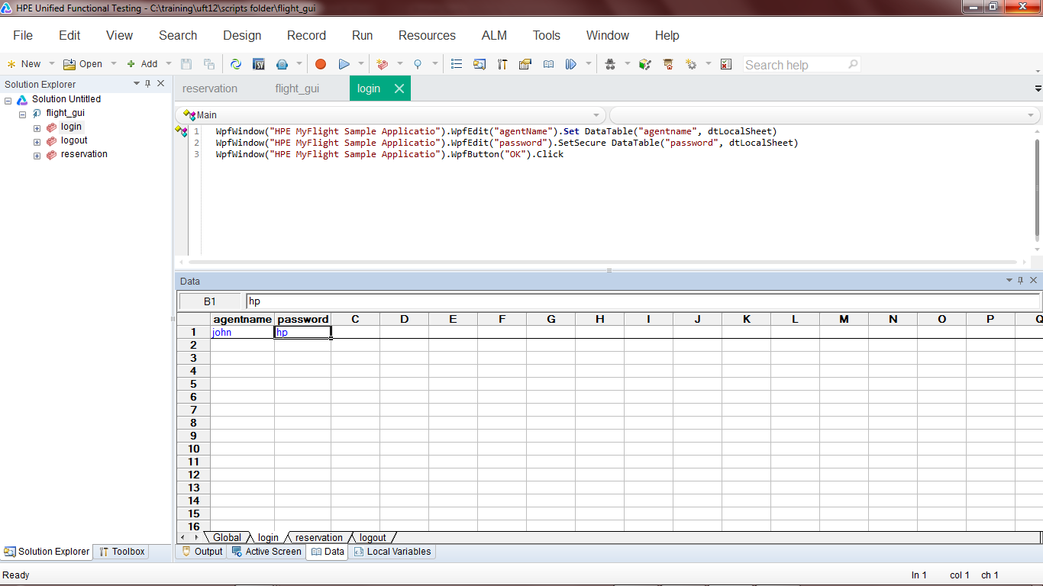

**Figure No-1: Application Login Script**

**1.2 Reservation Test:**

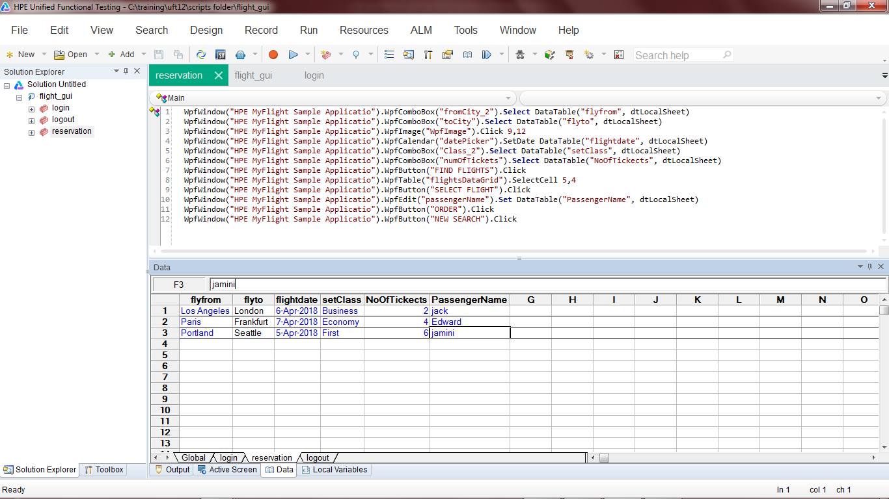

**Figure No-2: Application Reservation Script**

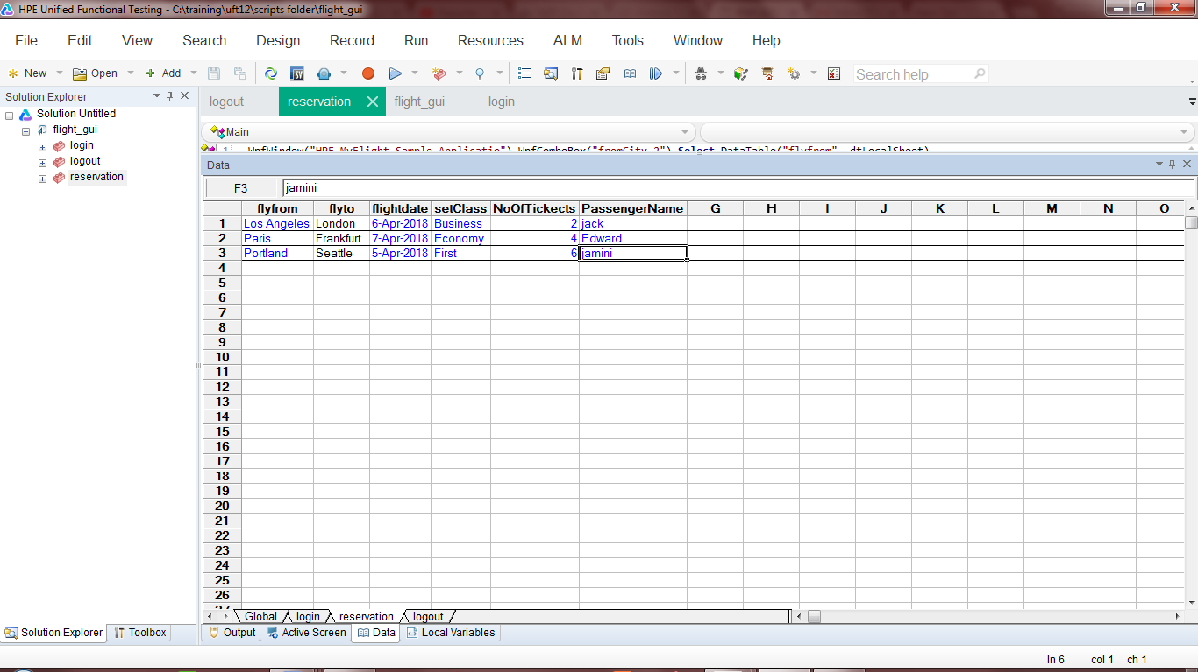

**Figure No-3: Application DataTable Parameterization**

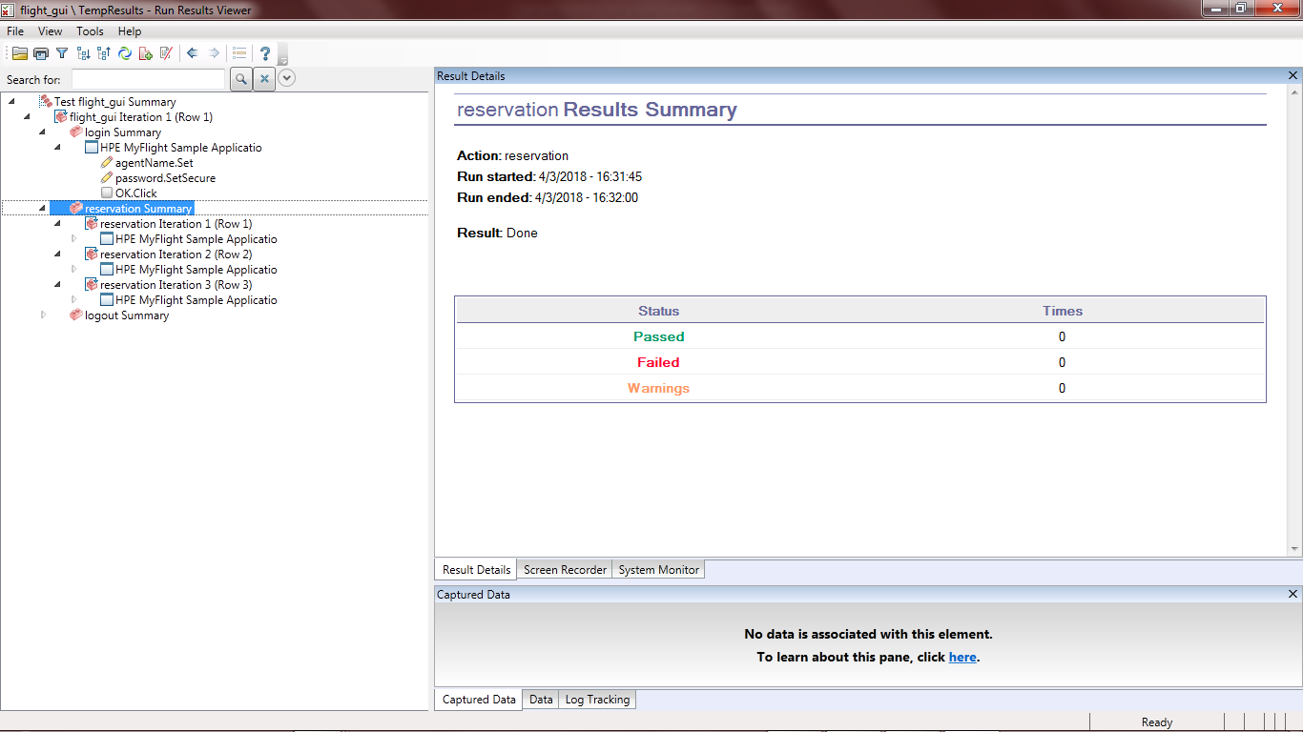

**Figure No-4: Application reservation Script Result Window**

**1.3 Logout Test:**

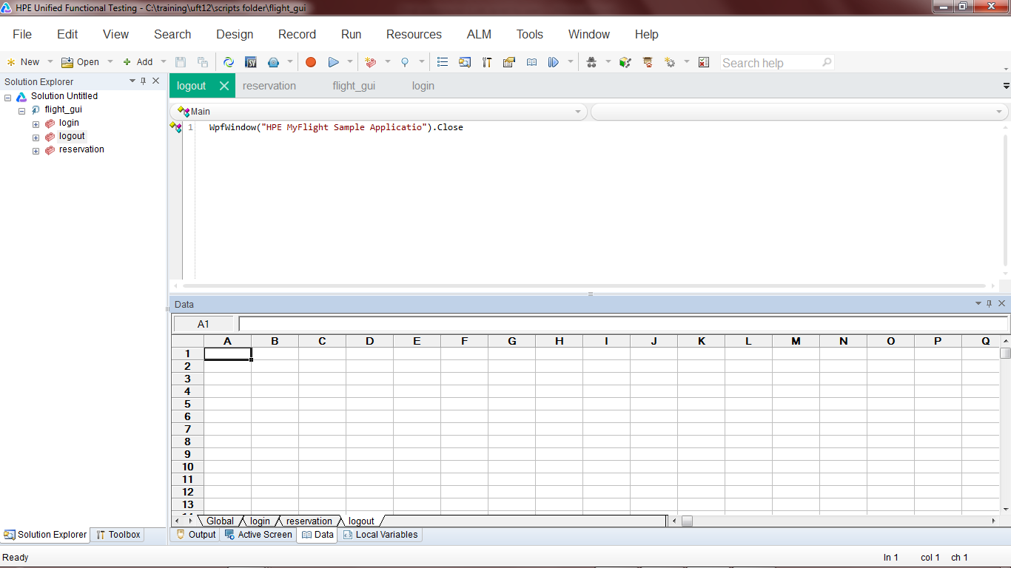

**Figure No-5: Application Logout Script**

**TASK2: Successful scenarios : getting property of “OK Button”:**

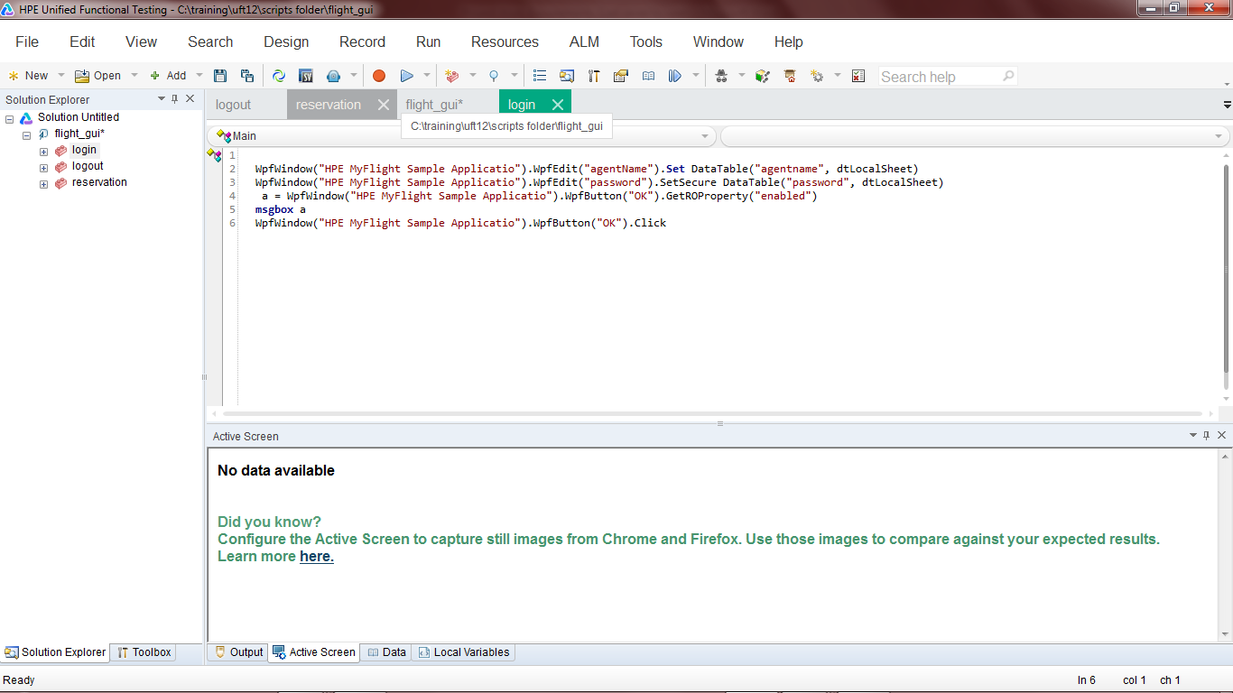**Figure No-6: ensuring enabling of OK button Script**

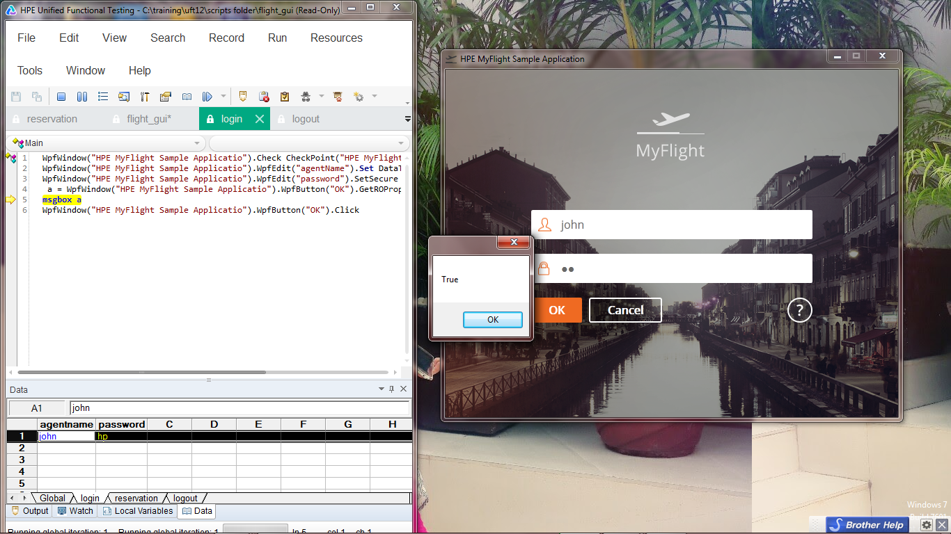

**Figure No-6: Checking enable/disable property of OK button**

**TASK 3: Select the origin (Fly From) and the destination (Fly To) cities randomly. Ensure that the script runs at least for 3 times.**

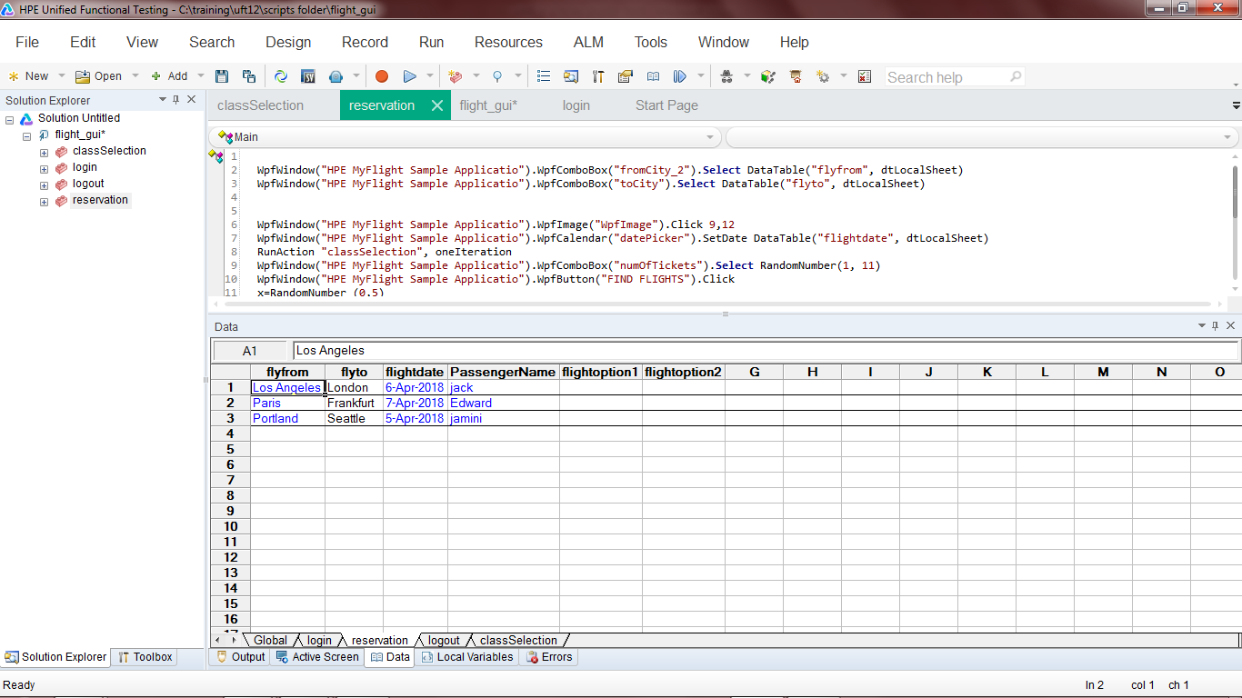

**Figure 7 Reservation Script**

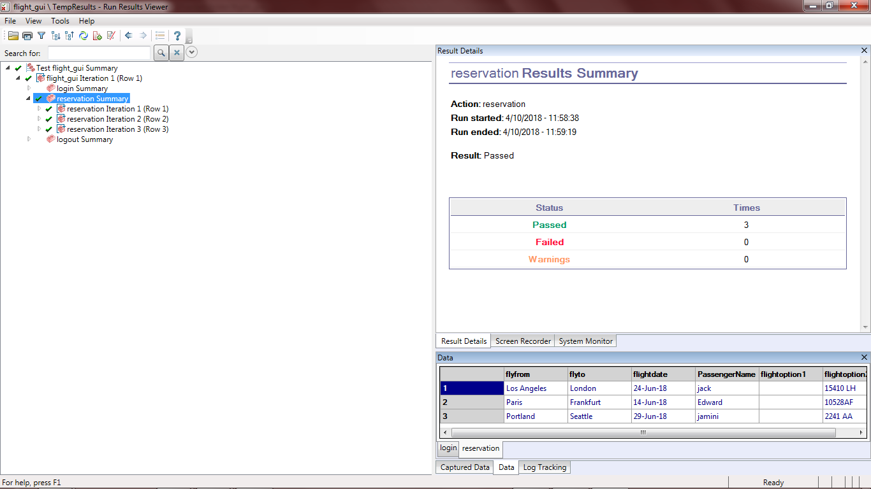

**Figure 8: Reservation successful iteration result.**

**TASK 4:** **Ensure that the flight is chosen randomly from the list**

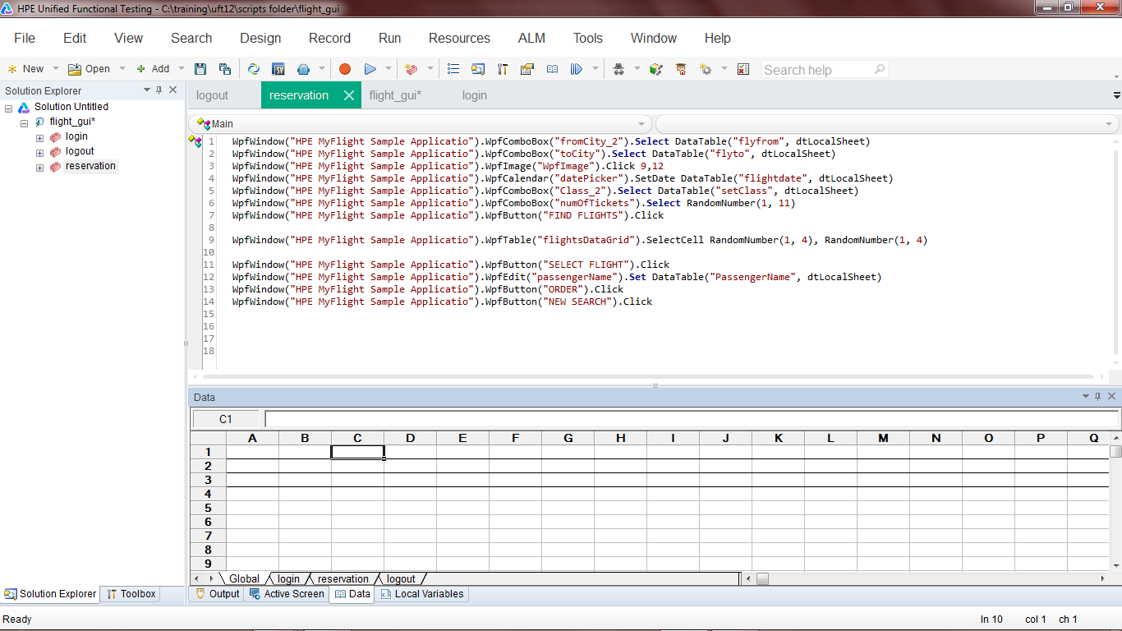

**Figure No-10: random flight selection Script.**

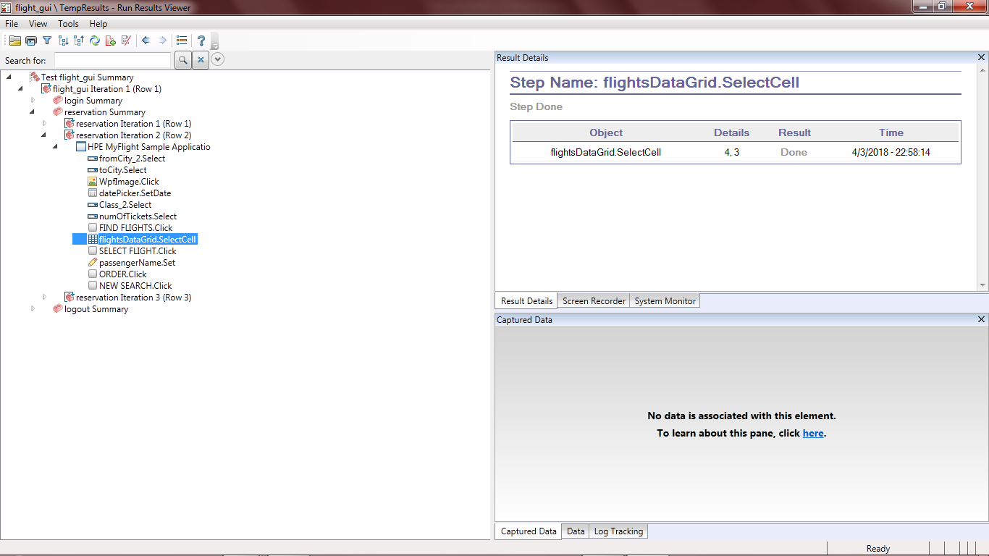

**Figure No-10: random flight selection result.**

**TASK 5:** **Ensure whatever flight option is chosen from the list the same gets populated in the application.**

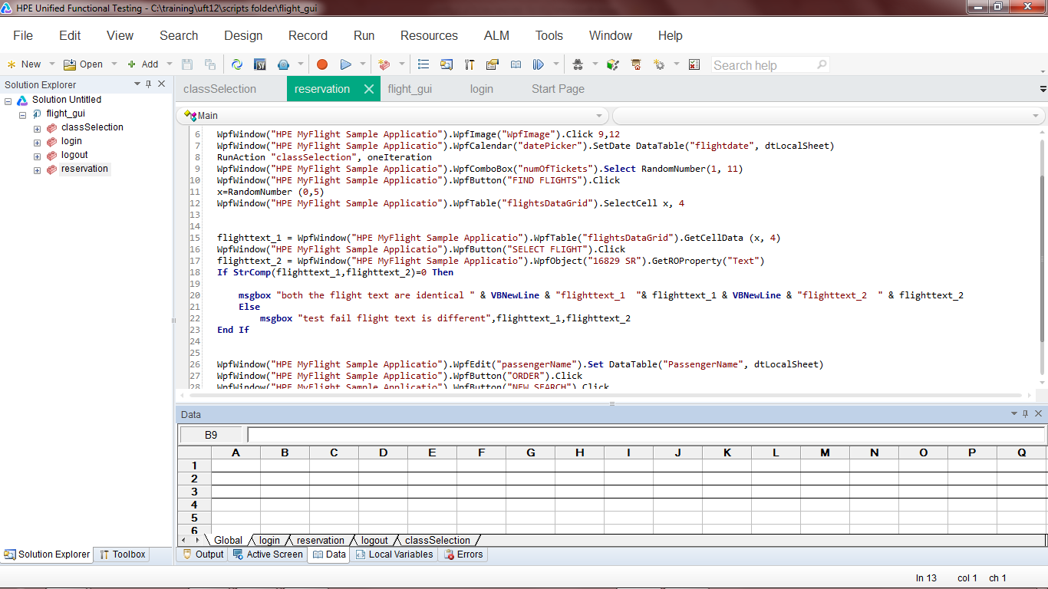

**Figure 11: condition to check both the identical flight string**

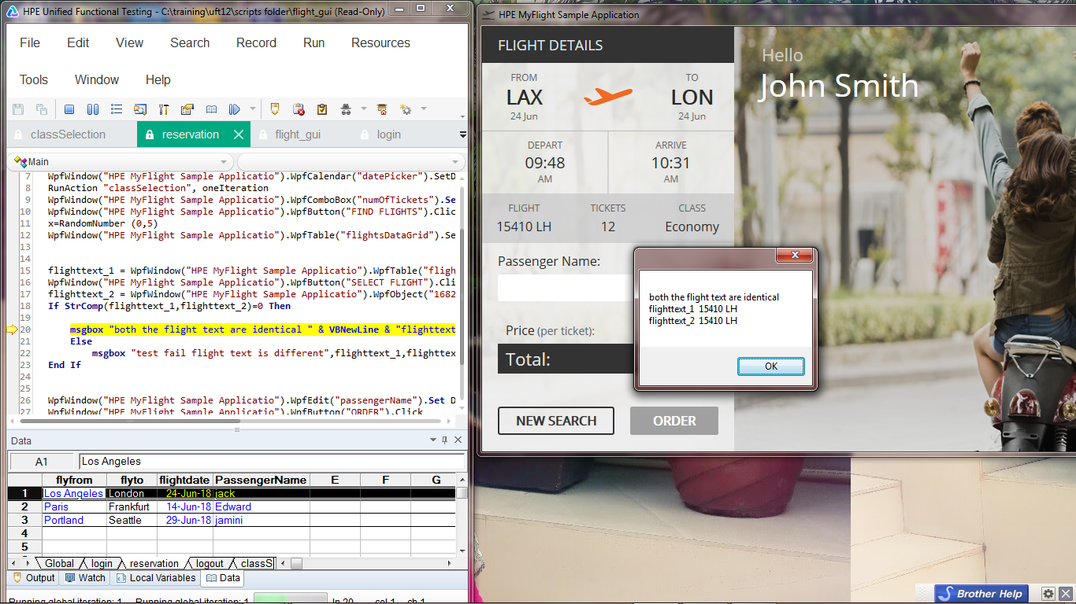

**Figure 12: result when strings are identical**

**TASK 6: Choose the number of tickets randomly and ensure that the number of tickets is less than 11.**

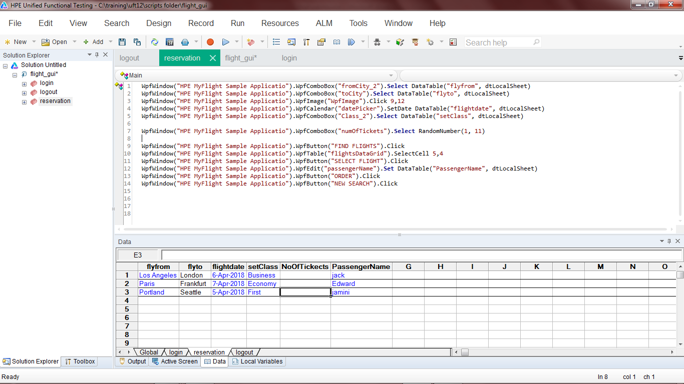

**Figure No-8: random tickets selection script**

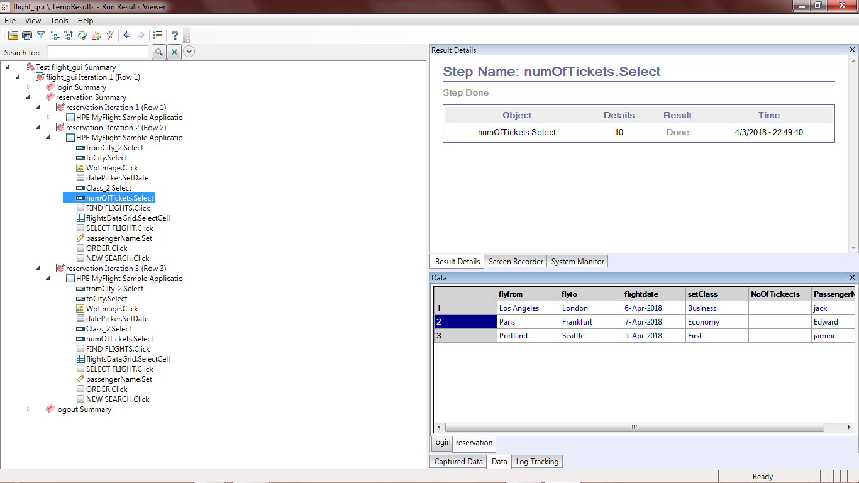

**Figure No-9: random tickets selection result.**

**TASK 7: Ask the user at run time for the class of travel using an input box. The user should enter F/B/E for indicating his class of travel either in First, Business or Economy class. Any other input from the user should give a message of invalid input and ask for his input again.**

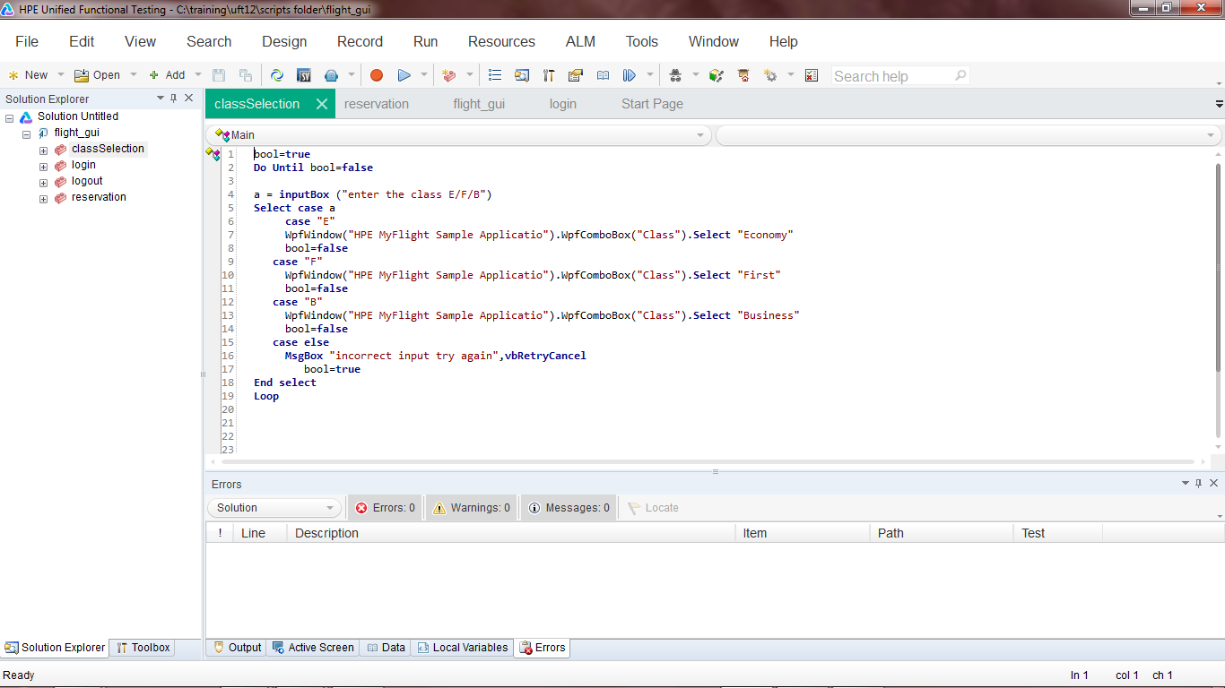

**Figure 13: Script to input class of travel by the user.**

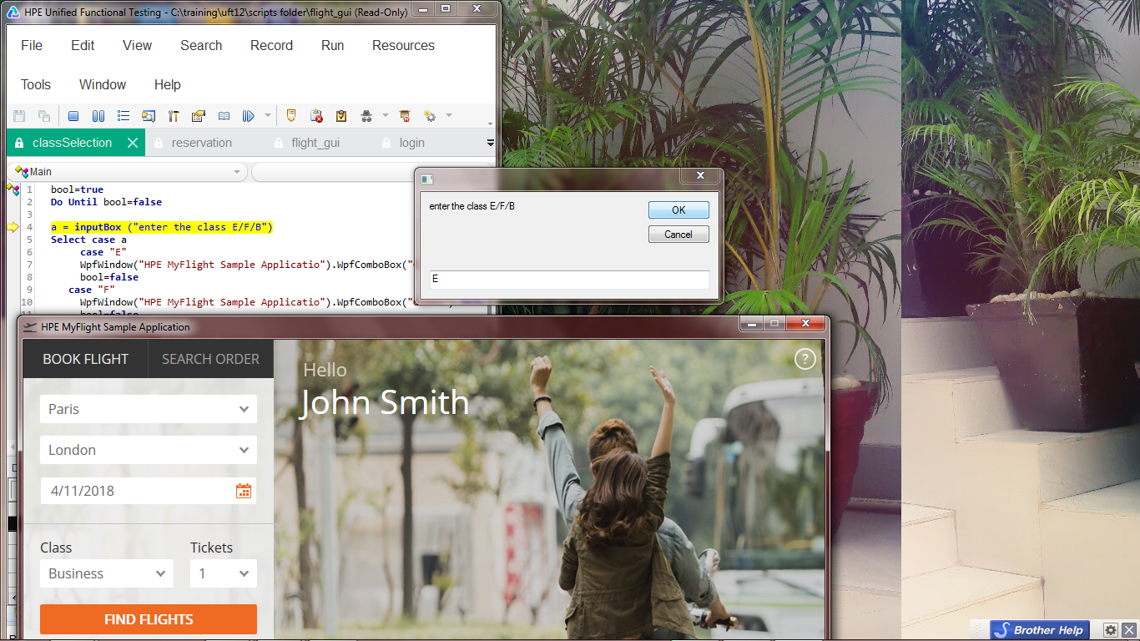

**Figure 14: Running example of input box.**

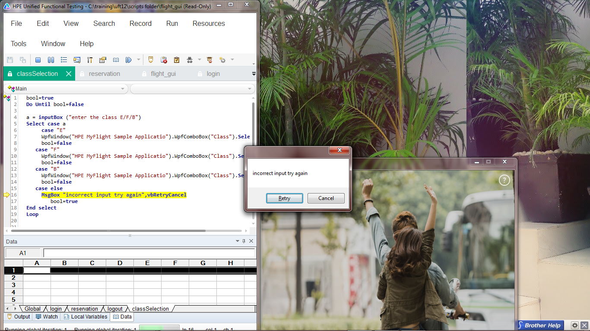

**Figure 15: message box will appear at runtime on invalid input.**

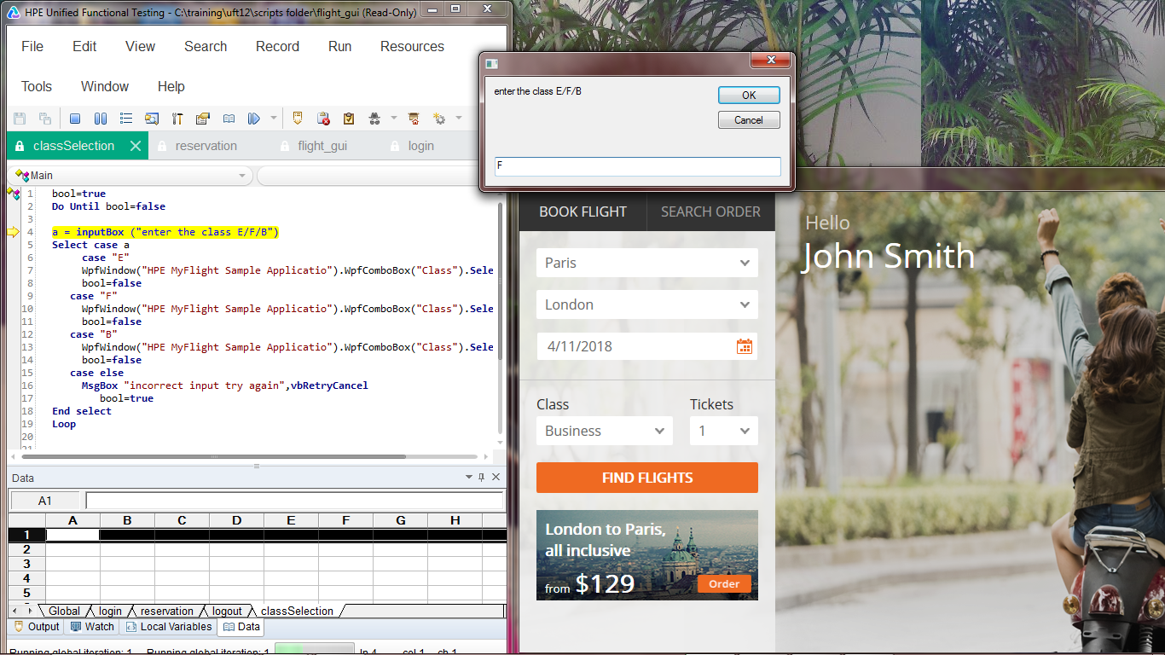

**Figure 16: Process will continue until it will get valid input.**

**TASK 8: Based on the value input by the user to indicate his class of travel, the class of travel should be accordingly chosen at runtime.**



**Figure 17: Script to populate the same value as got from the input box**



**Figure 18: taking input according to F/B/E.**

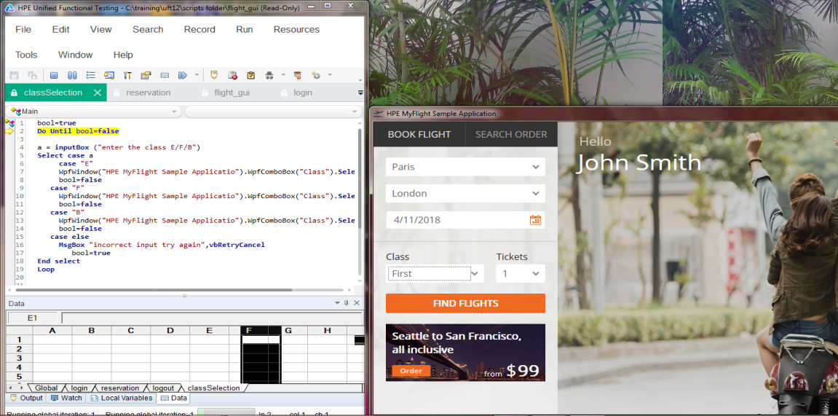

**Figure 19: showing the same value populated according to the user input.**

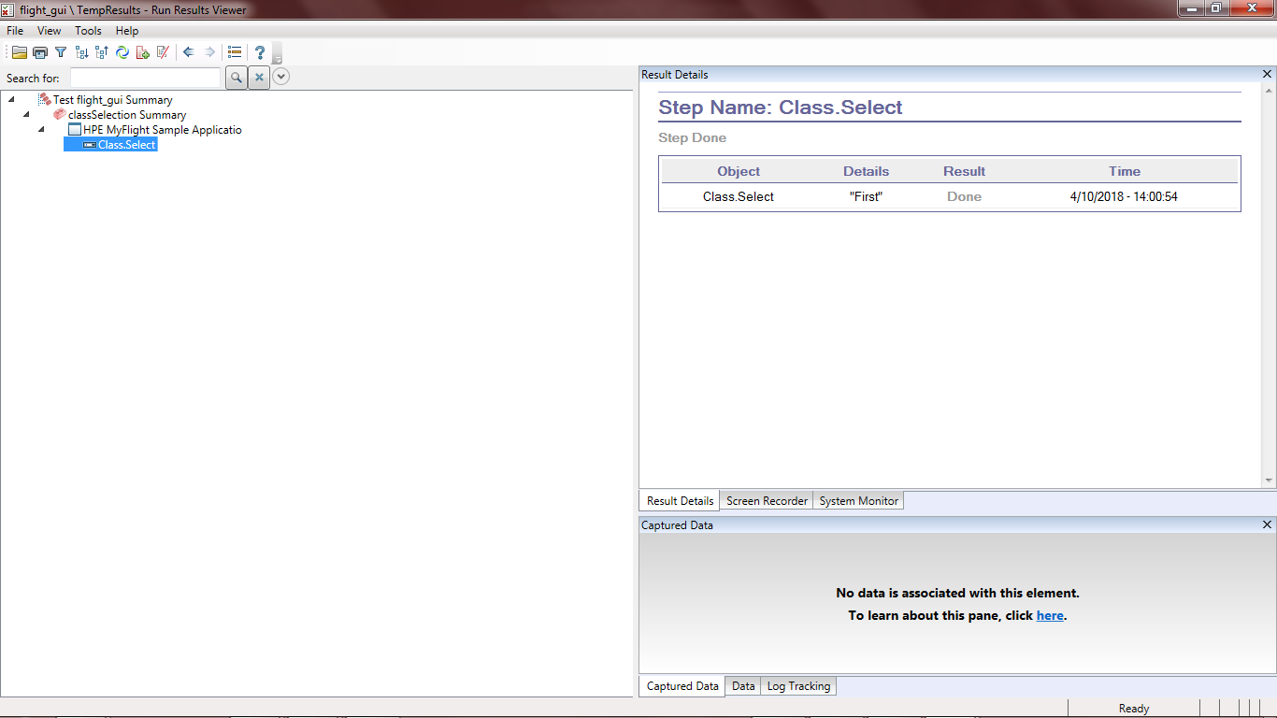

**Figure 20: Success result also showing the user selection at runtime**

**TASK 9:** **Validate that the number of tickets multiplied by the Price of each ticket is equal to the Total.**

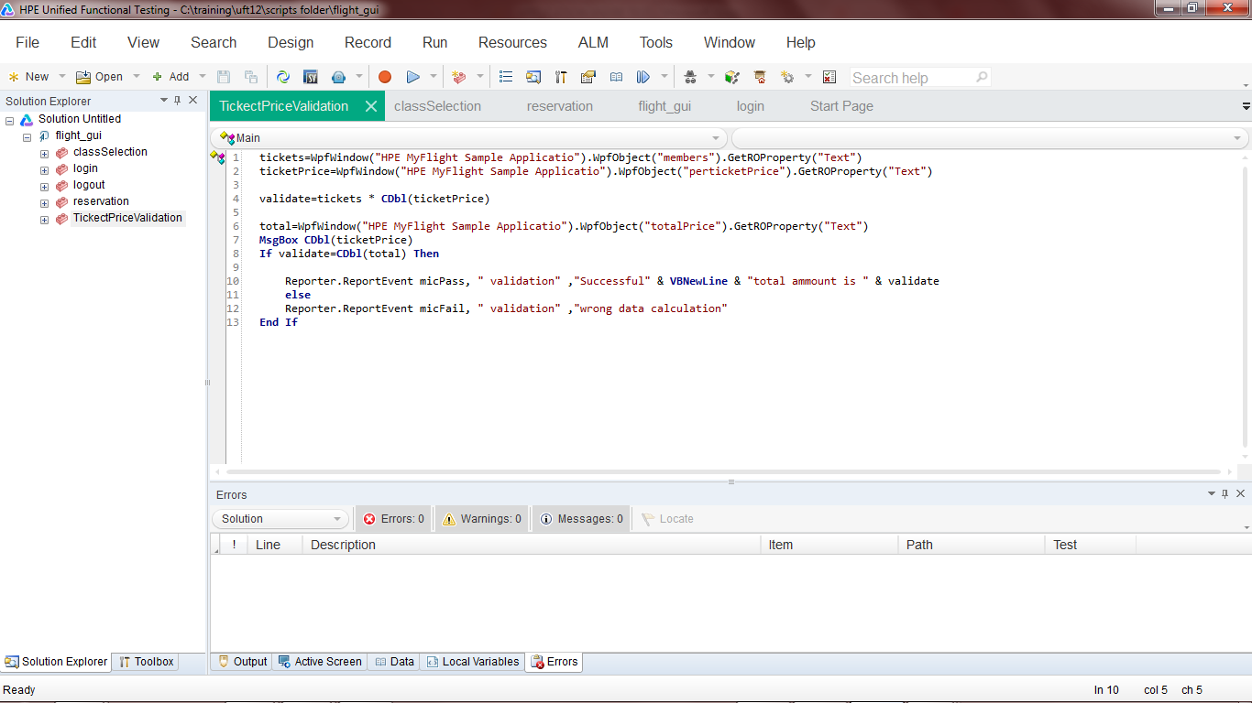

**Figure 21: Script to validate total amount of tickets according to number of passengers.**

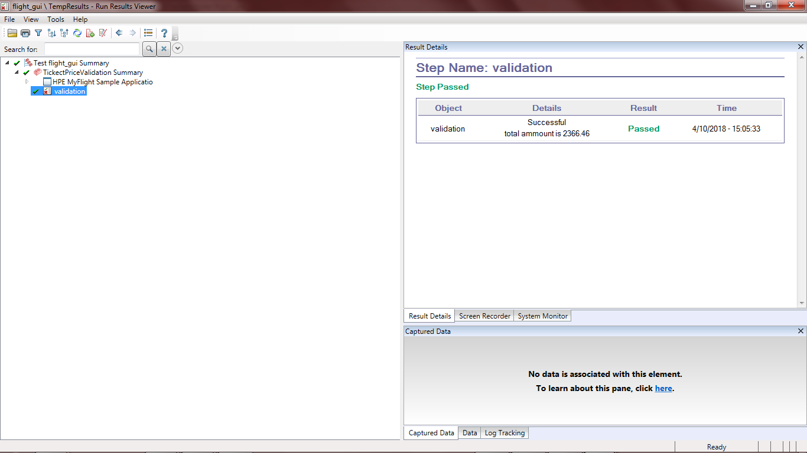

**Figure 22 : Successful result of validation**

**TASK 10: Click on Order button to book the ticket and retrieve the order number from the displayed message.**

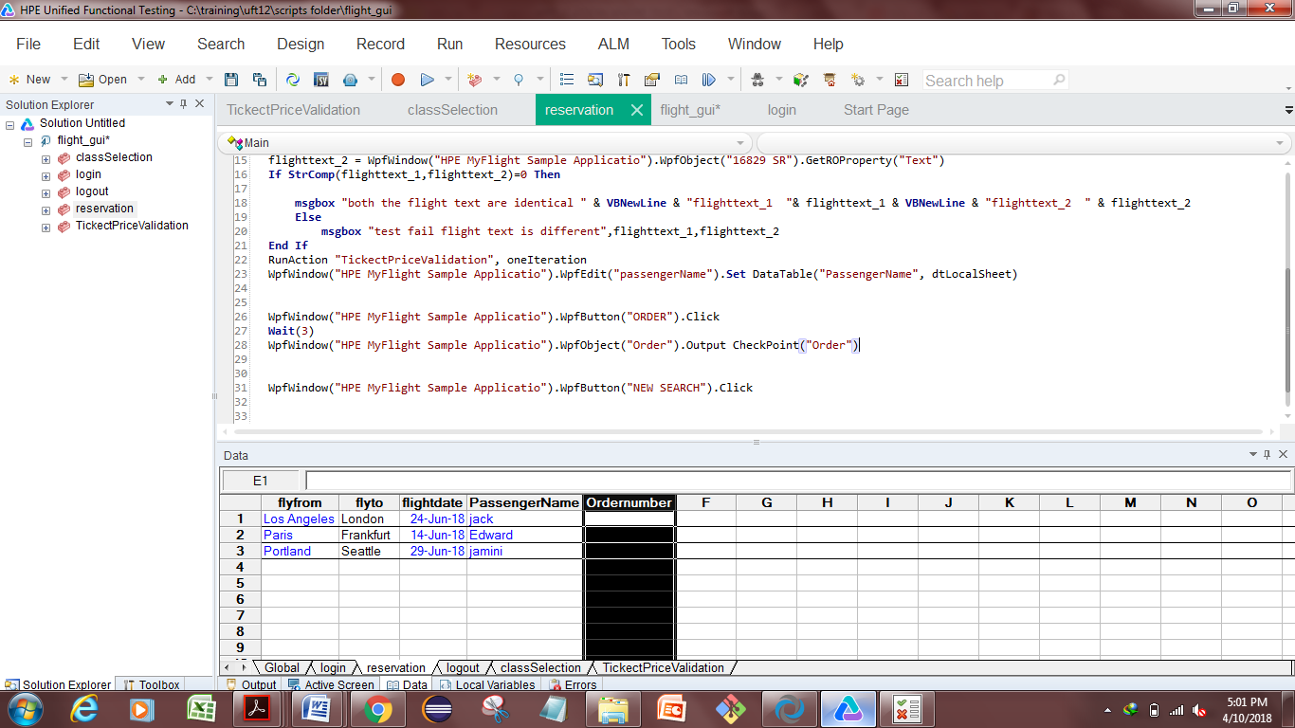

**Figure 23: Setting output parameter to retrieve order number.**

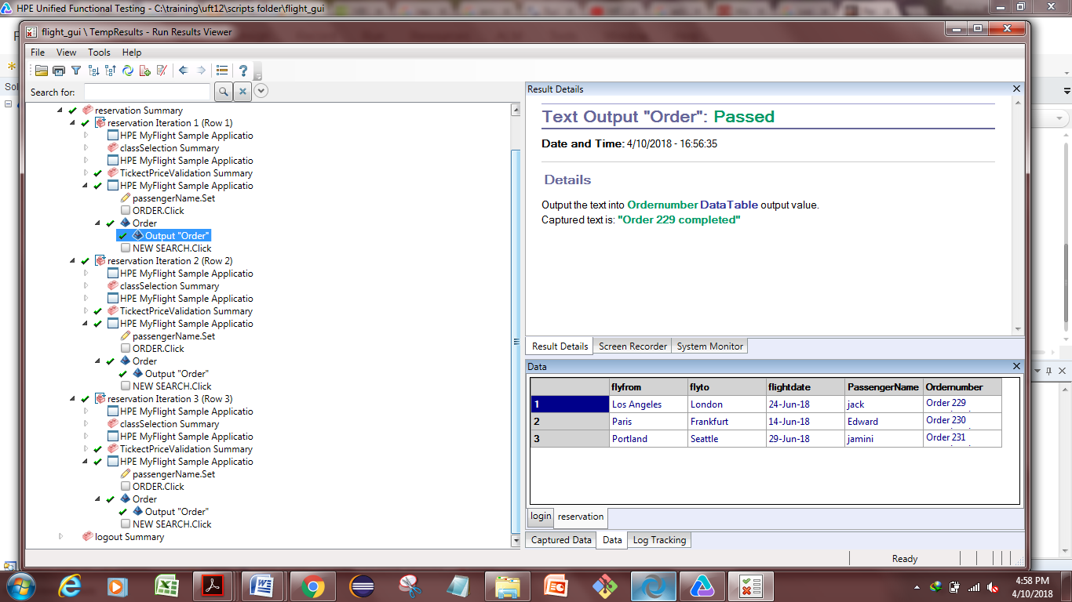**Figure 24: successful test results in which a column is showing the output parameters retrieved from order number.**

1. **Conclusion:**

Marked requirements in ALM 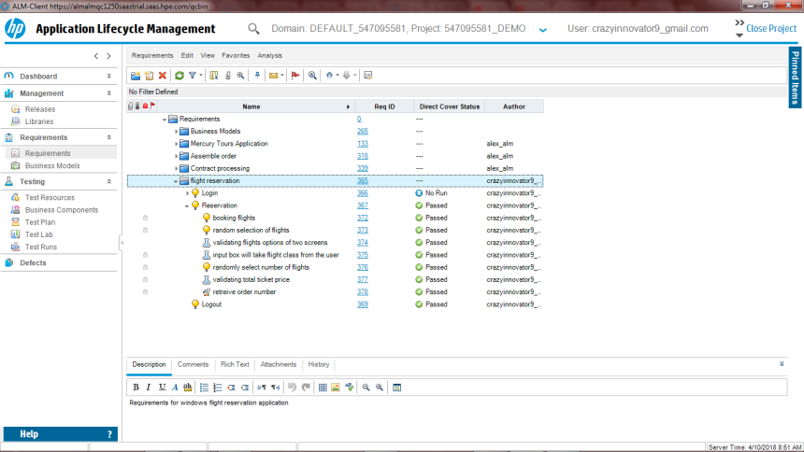

Figure: Requirements of AUT

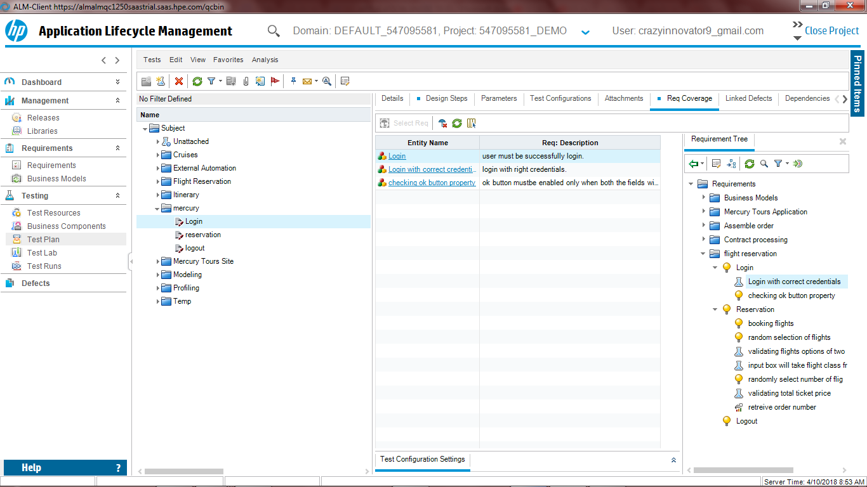

Figure : test coverage for login

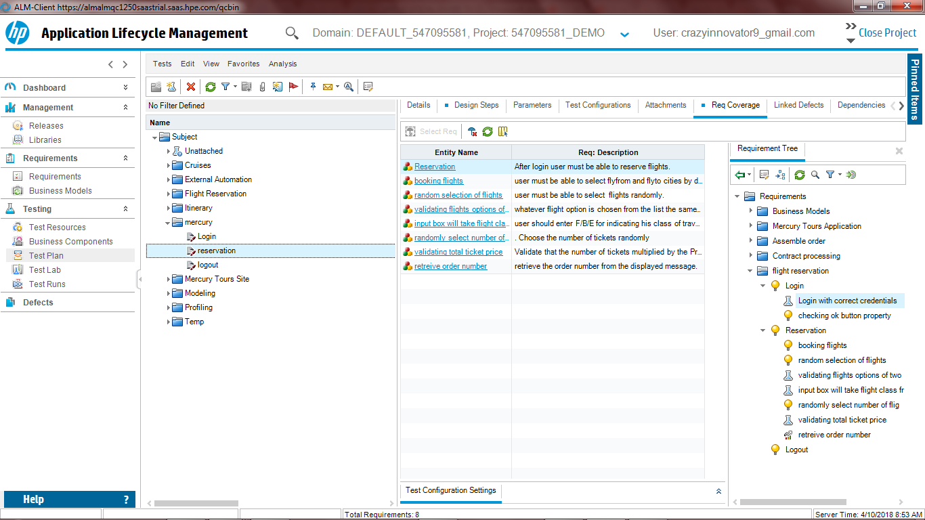

Figure : test coverage for reservation

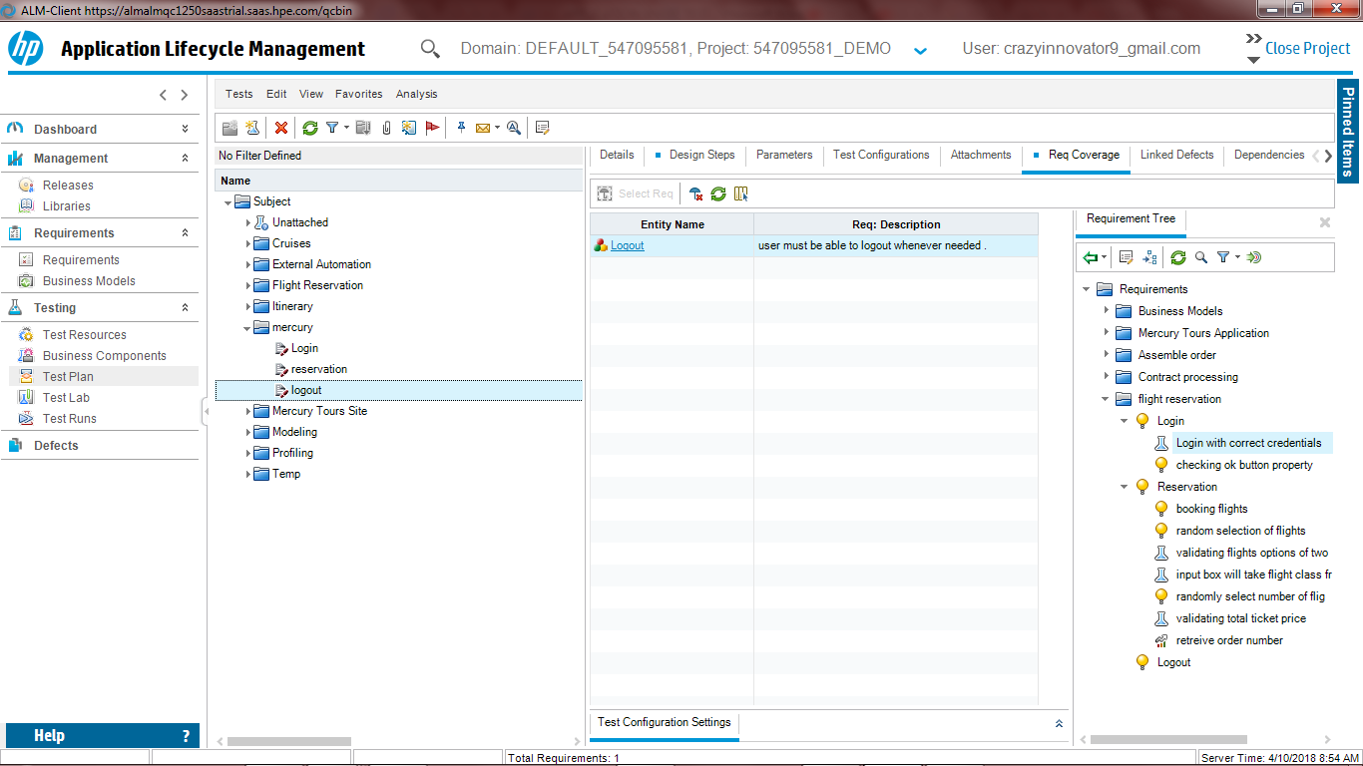

Figure : test coverage for logout.

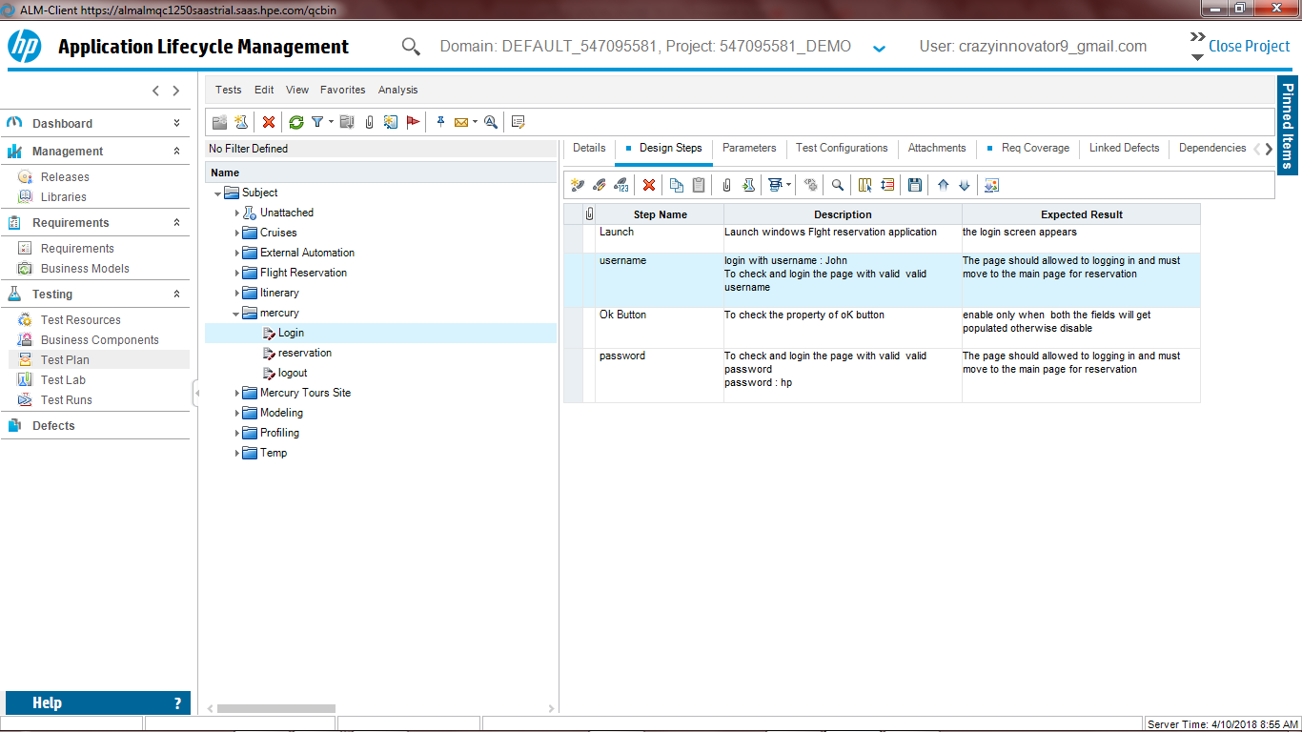

Figure: Design steps for Login.

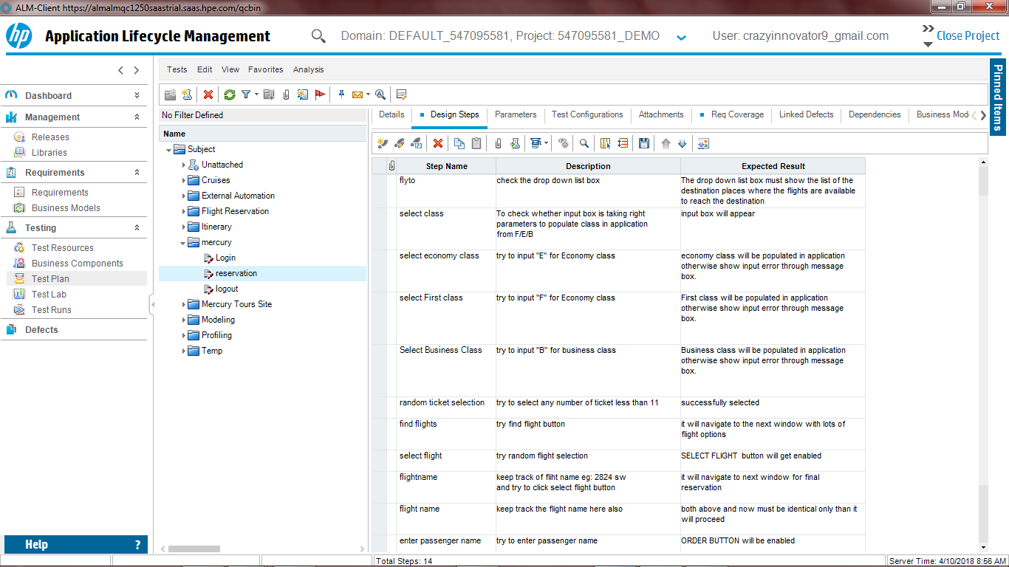

Figure: Design steps for Reservation.

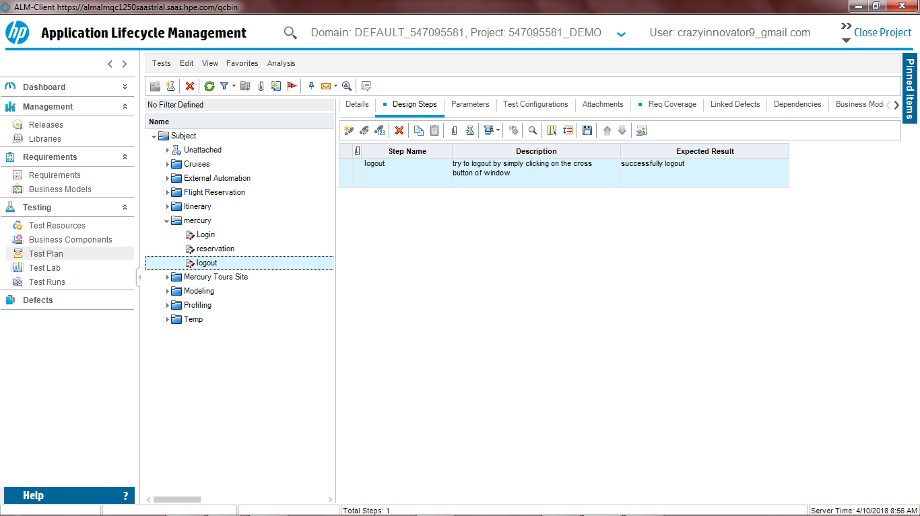

Figure : Design steps for Logout.

--End of Document--